How to find your OneNote ClassNotebook:
- Log in Office 365: portal.office.com
- Click on Class Notebook or Shared with Me
- Click on the proper Class Notebook

OneNote Class Notebook: Includes Four types of sub-notebooks: Teacher Notebook, Student Notebooks, Content Library and Collaboration Space. All notebooks can be found under Class Notebook or One Drive.
OneNote Class Notebook (Student Notebooks): Private notebooks that are shared between each teacher and their individual students. Teachers can access these notebooks at any time, but students cannot see other students’ notebooks.
OneNote Class Notebook (Content Library): A notebook for teachers to share course materials with students. Teachers can add and edit its materials, but for students, the notebook is read-only.
OneNote Class Notebook (Collaboration Space): a notebook for all students and the teacher in the class to share, organize, and collaborate.

Copying a page to your Student Notebook:

YOU MUST BE IN THE DESKTOP VERSION OF ONE NOTE 2016

Right click on the name of your page, a drop down should appear. Click “Copy or Move”. Choose a location that you would like it to be put into (choose your own notebook). Click on the + to the left of your notebook. Click the location that you want your page to go. Click Copy.

Office 365: Create, upload, share documents. If document is not compatible with Office 365 (ex: publisher) when opening you will be asked to access software on computer for editing, etc.. When creating documents in Office 365, document is automatically saved as you are working.

One Drive: One drive is where you can save documents in the cloud.

Office 365 vs. One Drive vs. OneNote Notebook:
- Office 365 is a set of cloud services available for personal, education or business activities.
- OneDrive is a free storage space provided by Microsoft. Type onedrive.com in your browser to find it.
- OneNote is a computer program for information gathering and multi-user collaboration. It gathers users' notes (handwritten or typed), drawings, screen clippings and audio commentaries.
New: Create folders or documents. Documents created in this format will save automatically.
Drag files/folders to Office 365: Can drag multiple documents by highlighting them and dragging to One Drive in Office 365 (limit of 100 files at a time).
Upload: Another method for uploading files. Browse for files then upload.
Sync: When in Office 365 if you click sync documents, documents created from computer software and saved on One Drive for Business will “sync” and save in favorites on your computer plus on Office 365. If using different computer, you will need to sync each computer. If you are working on the desktop version of One Note, Word, etc. You MUST sync your files to the cloud.
Share: Share “Files” or “Folders” by inviting people by name or everyone but external users (everyone but external users is all BCS domain) with “can edit” or “can view” options.
Shared With Everyone Folder: Can put documents in folder that you want to share with everyone. Documents do not automatically go to everyone’s “Shared with Me” area. Need to search to find documents. Would need to email people to let them know of this sharing.
Search: Search for documents (ex: documents that have been shared with everyone).
Shared with Me: Where documents appear that others have specifically shared with you.
HOW TO…

- Log In
  - Log in Office 365: portal.office.com
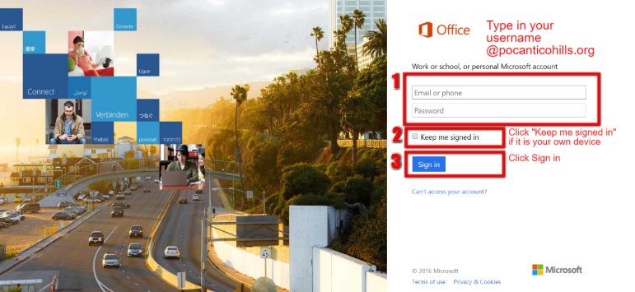
  - Click on the tile for where you want to go
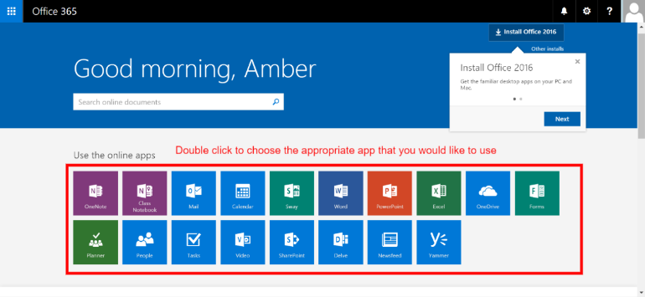
  - Find the notebook or document you are looking for. Search by name, date modified or by who created the document.
- Create Section in OneNote Notebook
  - Right-click any existing section tab in your notebook, and click New Section or Click on the + sign to create a new section.

  - Type a meaningful description for the new section, and press Enter.

- Create Page in OneNote Notebook
  - To create a new page, click the New Page button above the page tabs.

- Create Subpage in OneNote Notebook
  - To create a new subpage, click the New Page arrow and then click New Subpage.
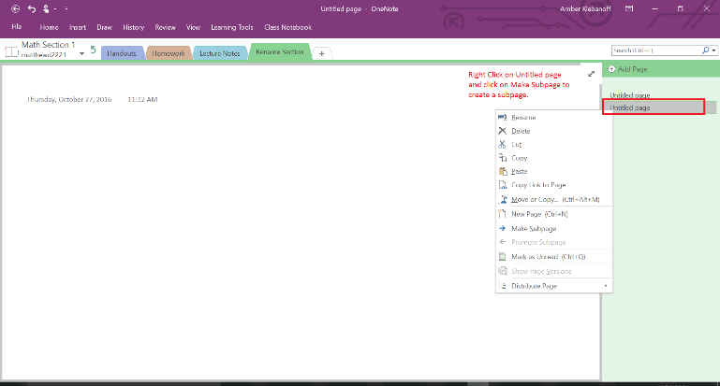
- Share Page in OneNote Notebook
  - Click on the page you want to share
  - Click Home in the top left corner
  - Click Email page
